1. 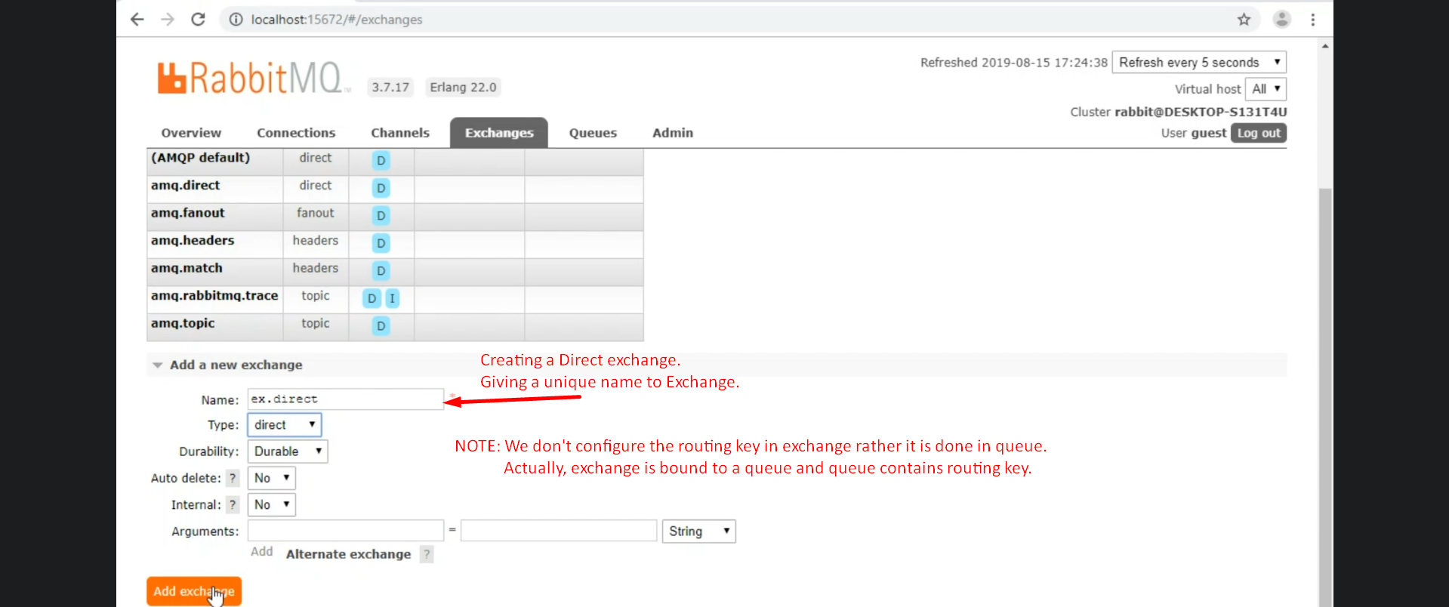  
   **Question**: Why can’t we configure routing key on exchange itself?  
   **Answer**: As one exchange can be bound to more than one queue and each queue will have its own routing key and exchange will check to which queue this msg is to be routed based of routing key. So all the queues whose routing key matches with the routing key in msg will get msg 😊.
2. Creating Queues  
   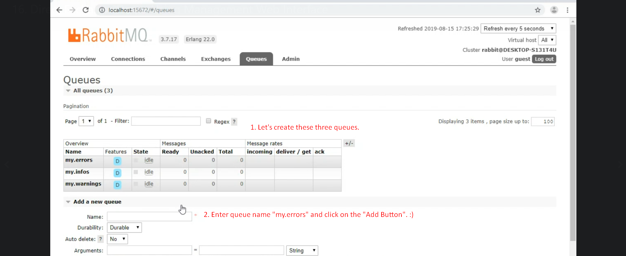
3. 
4. 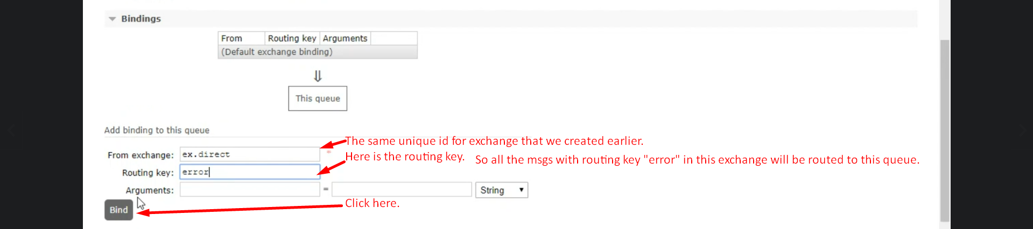  
   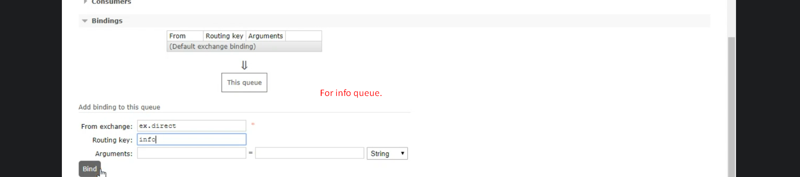
5. Let’s now publish messages to test direct exchange and binding. 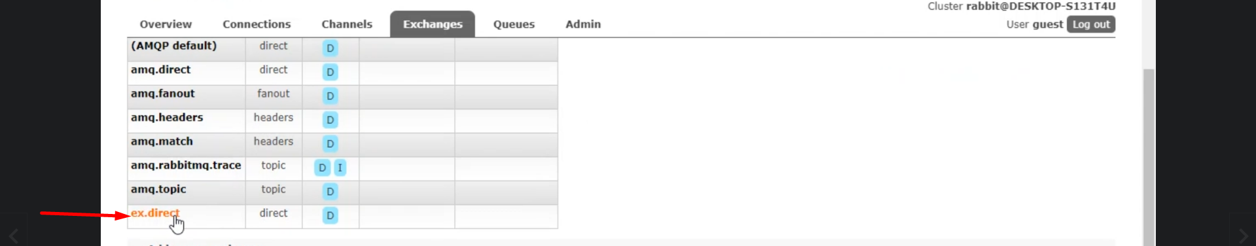  
   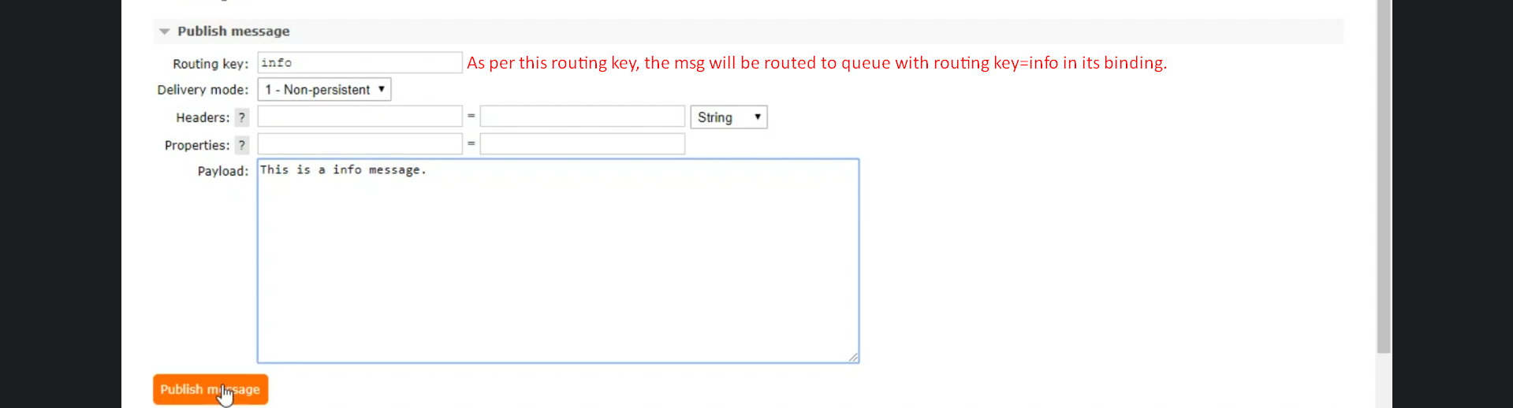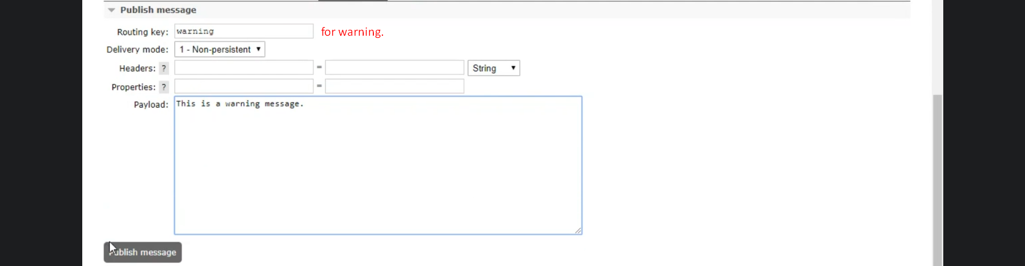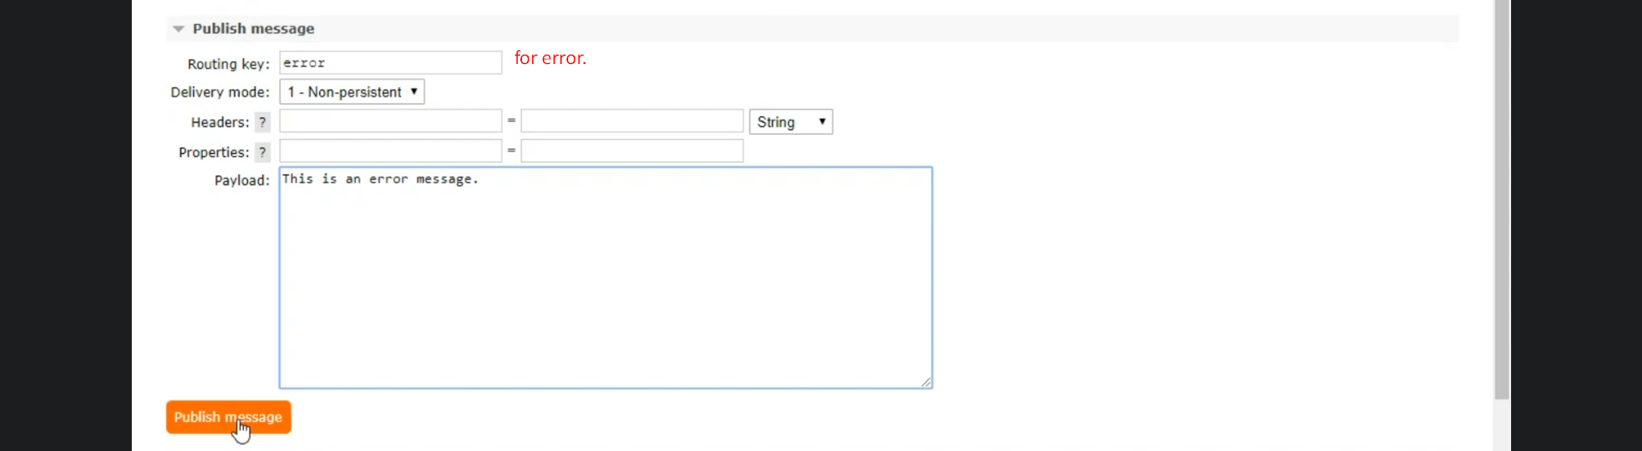
6. Now let’s check each queue. 